**When**: Saturday January 26th, 2019

**Where**: Grumpy’s / Rose Vine Hall

2801 Snelling Ave

Roseville, MN 55113

(651) 379-1185

**Plenty of free outdoor parking

**Time**: 6:00 pm – 9:00 pm  
 Doors open at 6:00pm. Dinner served at 6:30 pm  
 Presentation will start around 7:00pm

**Cost**: $25/person (non-alcoholic beverages included)

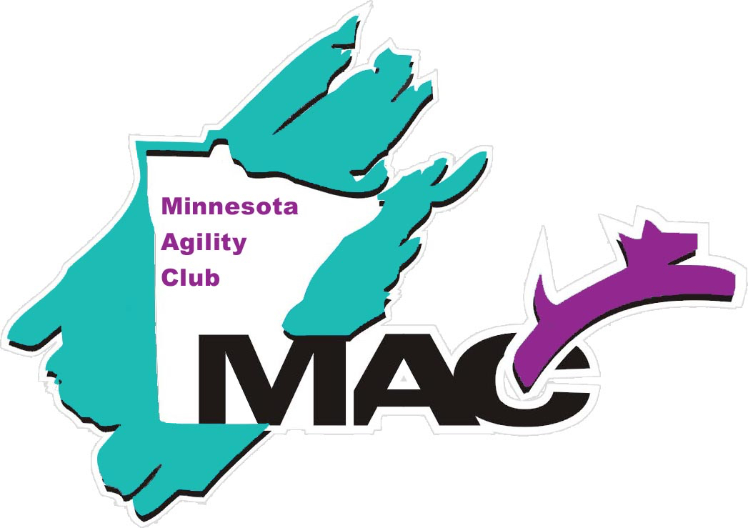

**Please send reservations to: Sue Kvale, 9510 400th Street, Cannon Falls, MN 55009**

Name(s):

Phone:

Email Address:

Number attending banquet __________ x $25 = ________________ (total amount enclosed)

**Dinner will be a Build-Your-Own Taco buffet including:**

Flour tortillas, corn shells, shredded chicken, ground beef, fajita vegetable mix, refried beans, Spanish rice, diced tomatoes, onions, lettuce, cilantro sour cream, shredded cheddar, salsa and guacamole.

**RSVP:** Return the bottom of this page with payment (checks payable to Minnesota Agility Club) to Sue Kvale by ***Friday January 11, 2019***

If you have questions, please call or email me at 952-457-1681 or [kvale7727@frontiernet.net](mailto:kvale7727@frontiernet.net)

2018 Minnesota Agility Club Banquet