When: Saturday January 13th, 2018

Where: Grumpy’s / Rose Vine Hall
2801 Snelling Ave
Roseville, MN 55113
(651) 379-1185
**Plenty of free outdoor parking
Time: 6:00 pm – 9:00 pm
Doors open at 6:00pm. Dinner served at 6:30 pm
Presentation will start around 7:00pm

Cost: $25/person (non alcoholic beverages included)

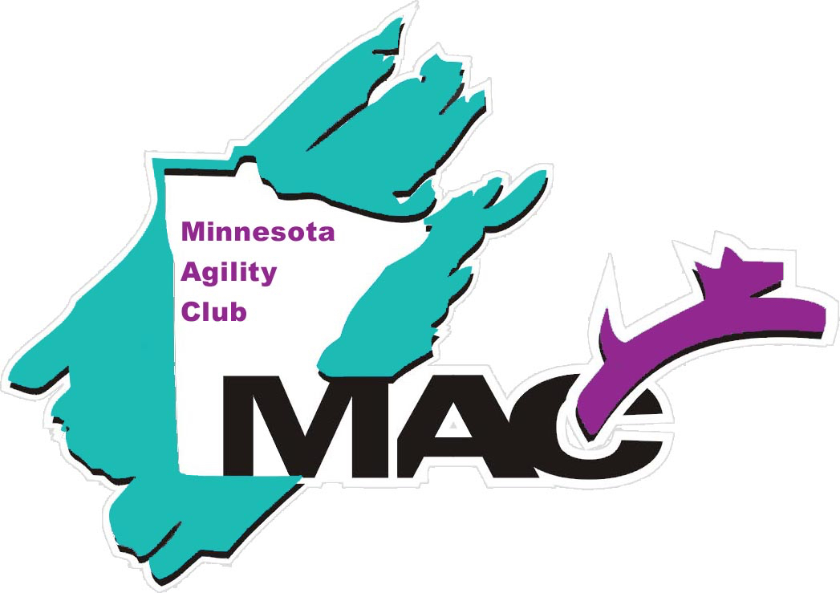

Please send reservations to: Leanne Wortman, 3910 Harbor Lane N, Plymouth, MN 55446-3322
Name(s)
Phone Email Address __________________________________________
Number attending banquet __________ x $25 = ________________ (total amount enclosed)
Dinner will be a buffet including the following items:
Meat lasagna, chicken fettuccine alfredo, and vegetarian homemade manicotti. Includes garlic bread, Caesar salad and fresh grated Parmesan cheese.

RSVP: Please return the bottom portion of this page with your payment (checks payable to Minnesota Agility Club) to Leanne Wortman by Friday December 15th. If you have questions, please call or email me at 612-232-6289 or MACYearEndAwards@yahoo.com.

2017 Minnesota Agility Club Banquet

